Short-Term Scientific Mission Grant
- APPLICATION FORM -

Action number: 21111
Applicant name:

Specify on which deliverable the Applicant will be working on during the prospected STSM:

Working Group 1: Compound libraries coordination and integration of compound design
Working Group 2 Integration of early phase studies and low environmental impact actions
Working Group 3 Coordination of in vitro-to-in vivo translation of OneHealth leads and candida
Working Group 4 Integration of R&D process-environmental studies and translation in informed whitepaper

Details of the STSM
Title:
Start and end date: DD/MM/YYYY to DD/MM/YYYY
Nr. of days: 000 (maximum 180 days)
Requested budget
a) x000 Euro for travel
b) x000 Euro for stay and meals (to justify)
c) x000 Euro total budget (=a+b)

Please refer to the table below:
 | STSM GRANT
 | mission duration
Hosting Lab Country | days <30 | 30< days <60 | 60< days <180
Member and Cooperating Country | 1.200 € | 2.400 € | 3.400 €
African and Caribbean Country | 2.000 € | 3.000 € | 4.000 €

Home institution:
Name of the applicant: ……….
Affiliation: ……….
Country: ……….
YRI: yes/no (YRI = Young Researcher and Innovator, 40 years old maximum, as indicated in the COST Action rules)
Host institution:
Name: ……….
Affiliation: ……….
Country: ……….
Please provide a letter/email of the host that confirms the intent to host the STSM applicant.

Summary
(max.200 words)
Goals of the STSM

(max.200 words)
Applicant enters max. 200 word summary here.
Working Plan
Description of the work to be carried out by the applicant, methods used.
(max.500 words)
Applicant enters max. 500 word summary here.
Expected outcome and contribution to the Action MoU objectives and deliverables
Main expected results and their contribution to the progress towards the Action WGs objectives (either research coordination and/or capacity building objectives) and deliverables. Describe what the output of your STSM will be, for instance:
a) the STSM contributes to a deliverable described in the MoU of the Action
b) the STSM results in a joint journal/conference publication (please indicate the journal/conference)
c) the STSM results in a joint research proposal
d) other output (give description)

(max.500 words)
Applicant enters max. 500 word summary here.

References

- Hosting Lab description

- Hosting Lab selection motivation

Dissemination plans

Publications plans, conference attendance including presentation of the work done during the STSM training
Benefits of the STSM

(max.200 words)

Please read the following guidelines and delete them before submitting your application.

----------------
How to apply on the COST web platform and supporting documentation
STSM – supporting documentation
♣ STSM grant Application (based on e-COST template*)
- enter your personal e-cost page
- Go to Grant application
- Select the grant type
- Select the Action CA21111
- Proceed by filing the grids
♣ Confirmation of the host on the agreement from the host institution in receiving the applicant
♣ Other documents required by the Action
-------------------
*COST Action web platform to access the Grant application
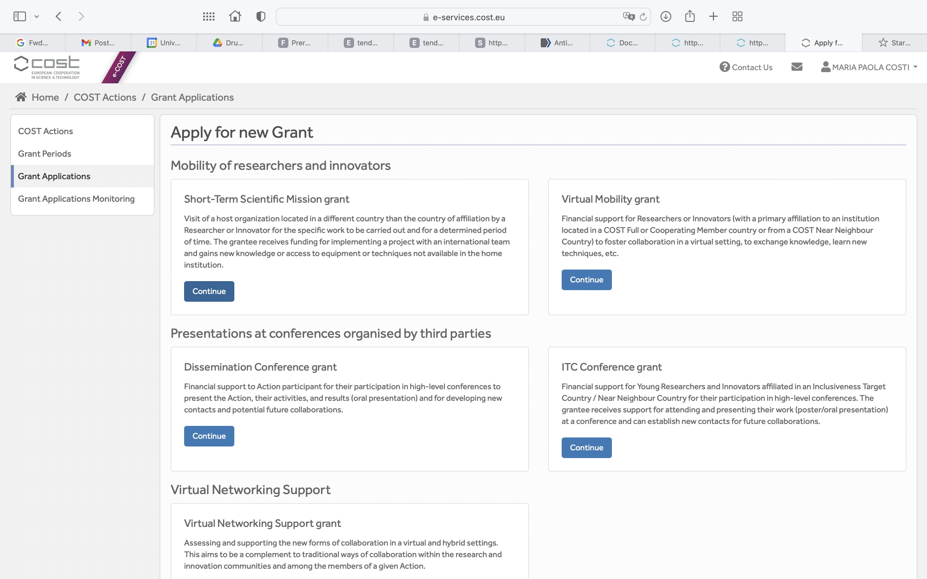
Step 1

Step 2
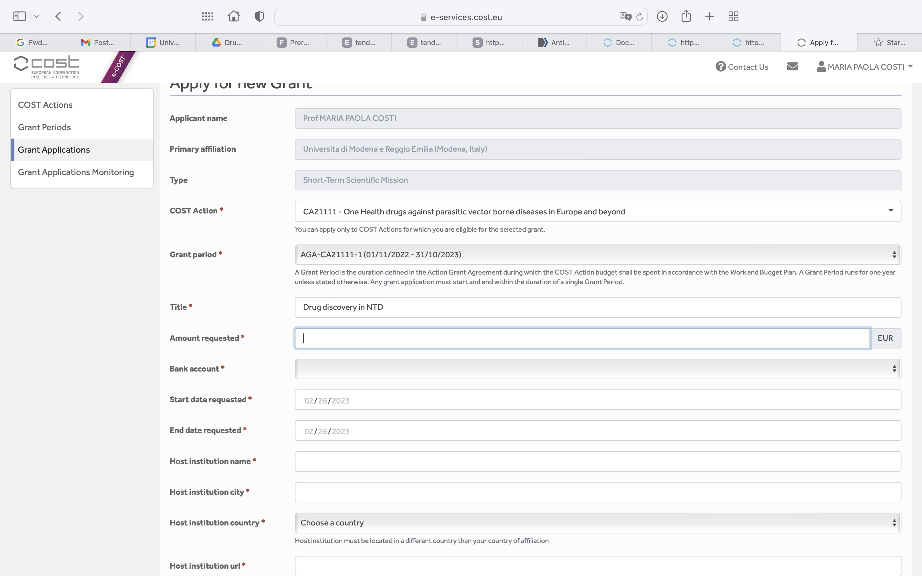
---------------------
Read Carefully the Grant awarding User guide. This is enclosed, but it can also be found in the cost website.

This form is part of the application for a grant to visit a host organisation located in a different country than the country of affiliation. It is submitted to the COST Action MC via-e-COST. The Grant Awarding Coordinator coordinates the evaluation on behalf of the Action MC and informs the Grant Holder of the result of the evaluation for issuing the Grant Letter.

